Challenging Glass Conference Proceedings – Volume 8 – June 2022
Conference on Architectural and Structural Applications of Glass
Challenging Glass 8 – 23 & 24 June 2022 – Ghent University – Belgium
Insert your paper title here
Firstname Lastname ª, Firstname Lastname ^{b}, Firstname Lastname ^{c}
- Affiliation, Country, e-mail (e-mail only for first or corresponding author)
- Affiliation (if different from other authors), Country
- Affiliation (if different from other authors), Country
Abstract
This is the abstract text, which should be about 1500 characters (including spaces) in length. This is the abstract text, which should be about 1500 characters (including spaces) in length. This is the abstract text, which should be about 1500 characters (including spaces) in length. This is the abstract text, which should be about 1500 characters (including spaces) in length. This is the abstract text, which should be about 1500 characters (including spaces) in length. This is the abstract text, which should be about 1500 characters (including spaces) in length. This is the abstract text, which should be about 1500 characters (including spaces) in length. This is the abstract text, which should be about 1500 characters (including spaces) in length. This is the abstract text, which should be about 1500 characters (including spaces) in length. This is the abstract text, which should be about 1500 characters (including spaces) in length. This is the abstract text, which should be about 1500 characters (including spaces) in length. This is the abstract text, which should be about 1500 characters (including spaces) in length. This is the abstract text, which should be about 1500 characters (including spaces) in length. This is the abstract text, which should be about 1500 characters (including spaces) in length. This is the abstract text, which should be about 1500 characters (including spaces) in length. This is the abstract text, which should be about 1500 characters (including spaces) in length.
Keywords
Glass, Conference, Paper, Template, Lay-out
Article Information (this info will be filled later by the editors)
Digital Object Identifier (DOI): https://doi.org/10.7480/cgc.8.xxxx
Received: xx January 2022; Accepted: xx March 2022, Published: 23 June 2022
Cite this article: name of authors [if more than 3 authors use the name of the 1st author followed by et al. e.g Smith et al.], title of the article, Challenging Glass Conference Proceedings, volume 8, 2022, DOI 10.7480/cgc.8.xxxx
This work is licensed under a Creative Commons Attribution 4.0 International (CC BY 4.0) license.
©2022 [name of the author(s)] published by Challenging Glass on behalf of the authors

- Important Guidelines
This document provides the template for Challenging Glass. Please prepare your Challenging Glass paper using this template, without making any adjustments to the font styles, colours and margins.
Please note the following:
- Use the different GCC text styles to prepare your paper. You can see the different styles by using the key-combination Alt+Ctrl+Shift+S. Each style-name in this template starts with CGC followed by a short descriptor, e.g. CGC BodyText (for the main text) and CGC Caption (for captions), etc.
- When copy-pasting text into this template, please use the option “Paste Special > Unformatted Text” so to prevent the use of wrong text styles.
- The Article Information and footer information will be completed by the Conference Organisers.
- The following items should all fit on the first page: Paper Title, Authors, Abstract, Keywords and Article Information.
- The typical length for a CGC conference paper is 6 – 10 pages, but no specific page limit is set.
- Only SI-units should be used. Imperial units such as inches, pounds, etc. should not be used.
- For headings, use text style CGC Heading 1 or 2. No deeper subheadings should be used.
- For citations and references, have a look at the instructions in section 2 of this template.
- For Figures and Tables, have a look at the instructions in section 3 of this template.
- For Equations, have a look at the instructions in section 4 of this template.
- For Lists, have a look at the instructions in section 5 of this template.
- Citations and References
  - Citations
Cite references in the text by name and year in parentheses. Some examples:
- Negotiation research spans many disciplines (Thompson 1990).
- This result was later contradicted by Becker and Seligman (1996).
- This effect has been widely studied (Abbott 1991; Barakat et al. 1995; Kelso and Smith 1998; Medvec et al. 1999).
  - References
For the list of references at the end of the document, the text style CGC references should be used. The list of references should only include works that are cited in the text and that have been published or accepted for publication. Personal communications and unpublished works should only be mentioned in the text. Do not use footnotes or endnotes as a substitute for a reference list. Furthermore, please note the following:
- References should be given in alphabetical order by the last name of the first author of each work.
- If available, please always include DOIs as full DOI links in your reference list (e.g. https://doi.org/abc).
- Always use the standard abbreviation of a journal’s name according to the ISSN List of Title Word Abbreviations, see ISSN.org LTWA. If you are unsure, please use the full journal title.
- Authors using EndNote, could use the following EndNote style: EndNote style (zip, 2 kB).
- Some reference examples are given at the end of this template.
- Figures and Tables
  - Figures
Figures should be embedded in the word document. Use figures of at least 300 dpi.
To avoid Figures going wandering through the word document, they should preferably be placed in a table, with no visible borders. For this table, use the table style CGC Figure Table Grid. You can assign the style in the menu “Table Tools > Design” which appears when you click with your cursor in the table.
Below the Figure, insert a caption using the text style CGC Caption.
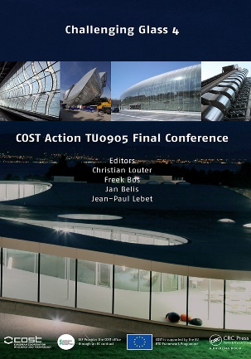 |  |  | 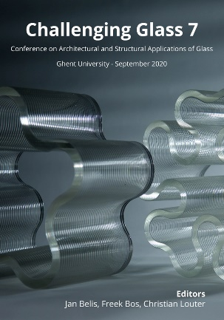
Fig. 1: Covers of the Challenging Glass Proceedings. This caption should appear in the text style CGC Caption.
Here the body text continues in style CGC BodyText.
  - Tables
For text Tables insert a Table with the appropriate number of columns and rows and assign the table style CGC Table Grid. You can assign the style in the menu “Table Tools > Design” which appears when you click with your cursor in the Table.
A table should always have the full page width. In printing, only the horizontal lines should be used at the very top and bottom of the table, and below the column headings. No vertical lines shall be visible. Cells may be split or joined by the author, if required.
Use the text style CGC Table Content for the text in the Table.
Above the Table, insert a caption using the text style CGC Caption.
Table 1: An example of required Table lay-out. This caption should appear in the text style CGC Caption.
Specimen | Section Dimensions [mm] | Span [mm] | Failure load F [kN]
1 | 300 x 10 | 3000 | 7.2
2 | 300 x 20 | 3000 | 13.9
3 | 450 x 12 | 4500 | 23.1
4 | 450 x 30 | 4500 | 38.5
After the table a blank line should be inserted to continue the body text in text style CGC BodyText.
- Equations
Use the text style CGC Equation and the word equation editor for equations. Number equations in parenthesis flush with the right margin. Do not use blank lines between the text and the equations. Example:
(1)
Here the body text continues in text style CGC BodyText.
- Lists
Different list styles can be used.
Below you find an example of a list with bullets.
- Text style = CGC List with bullets
- Text style = CGC List with bullets
- Text style = CGC List with bullets
Below you find an example of a list with letters.
- Text style = CGC List with letters
- Text style = CGC List with letters
- Text style = CGC List with letters
Below you find an example of a list with numbers.
- Text style = CGC List with numbers
- Text style = CGC List with numbers
- Texts style = CGC List with numbers
Here the body text continues in text style CGC BodyText. Please double-check the style!
Acknowledgements
Acknowledgements can be added at the end of the paper, before the references.
References (examples)
Broy, M.: Software engineering — from auxiliary to key technologies. In: Broy, M., Denert, E. (eds.) Software Pioneers, pp. 10–13. Springer, Heidelberg (2002)
Cartwright, J.: Big stars have weather too. IOP Publishing PhysicsWeb. http://physicsweb.org/articles/news/11/6/16/1 (2007). Accessed 26 June 2007
Geddes, K.O., Czapor, S.R., Labahn, G.: Algorithms for Computer Algebra. Kluwer, Boston (1992)
Hamburger, C.: Quasimonotonicity, regularity and duality for nonlinear systems of partial differential equations. Ann. Mat. Pura Appl. 169, 321–354 (1995)
Sajti, C.L., Georgio, S., Khodorkovsky, V., Marine, W.: New nanohybrid materials for biophotonics. Appl. Phys. A (2007). https://doi.org/10.1007/s00339-007-4137-z

